apiVersion: v1

kind: Pod

metadata:

  name: demo

spec:

  containers:

  - name: testpod

    image: alpine:3.5

    command: ["ping","8.8.8.8"]

Windows PowerShell

Copyright (C) Microsoft Corporation. All rights reserved.

Try the new cross-platform PowerShell https://aka.ms/pscore6

PS C:\Users\LENOVO\kubernetes> kubectl apply -f pod.yaml

pod/demo created

PS C:\Users\LENOVO\kubernetes> kubectl get pods

NAME READY STATUS RESTARTS AGE

demo 1/1 Running 0 27s

PS C:\Users\LENOVO\kubernetes> kubectl logs demo

PING 8.8.8.8 (8.8.8.8): 56 data bytes

64 bytes from 8.8.8.8: seq=0 ttl=37 time=30.864 ms

64 bytes from 8.8.8.8: seq=1 ttl=37 time=19.849 ms

64 bytes from 8.8.8.8: seq=2 ttl=37 time=71.236 ms

64 bytes from 8.8.8.8: seq=3 ttl=37 time=23.396 ms

64 bytes from 8.8.8.8: seq=4 ttl=37 time=19.271 ms

64 bytes from 8.8.8.8: seq=5 ttl=37 time=4123.064 ms

64 bytes from 8.8.8.8: seq=6 ttl=37 time=3115.734 ms

64 bytes from 8.8.8.8: seq=7 ttl=37 time=2081.619 ms

64 bytes from 8.8.8.8: seq=9 ttl=37 time=885.538 ms

64 bytes from 8.8.8.8: seq=10 ttl=37 time=841.118 ms

64 bytes from 8.8.8.8: seq=11 ttl=37 time=531.008 ms

64 bytes from 8.8.8.8: seq=13 ttl=37 time=20.458 ms

64 bytes from 8.8.8.8: seq=14 ttl=37 time=31.673 ms

64 bytes from 8.8.8.8: seq=15 ttl=37 time=20.192 ms

64 bytes from 8.8.8.8: seq=16 ttl=37 time=19.971 ms

64 bytes from 8.8.8.8: seq=17 ttl=37 time=43.553 ms

64 bytes from 8.8.8.8: seq=18 ttl=37 time=26.547 ms

64 bytes from 8.8.8.8: seq=19 ttl=37 time=20.452 ms

64 bytes from 8.8.8.8: seq=20 ttl=37 time=29.008 ms

64 bytes from 8.8.8.8: seq=21 ttl=37 time=23.138 ms

64 bytes from 8.8.8.8: seq=22 ttl=37 time=19.037 ms

64 bytes from 8.8.8.8: seq=23 ttl=37 time=19.386 ms

64 bytes from 8.8.8.8: seq=24 ttl=37 time=20.245 ms

64 bytes from 8.8.8.8: seq=25 ttl=37 time=21.806 ms

64 bytes from 8.8.8.8: seq=26 ttl=37 time=19.660 ms

64 bytes from 8.8.8.8: seq=27 ttl=37 time=20.444 ms

64 bytes from 8.8.8.8: seq=28 ttl=37 time=21.254 ms

64 bytes from 8.8.8.8: seq=29 ttl=37 time=24.512 ms

64 bytes from 8.8.8.8: seq=30 ttl=37 time=22.097 ms

64 bytes from 8.8.8.8: seq=31 ttl=37 time=19.785 ms

64 bytes from 8.8.8.8: seq=32 ttl=37 time=19.946 ms

64 bytes from 8.8.8.8: seq=33 ttl=37 time=22.596 ms

64 bytes from 8.8.8.8: seq=34 ttl=37 time=203.559 ms

PS C:\Users\LENOVO\kubernetes> kubectl delete -f pod.yaml

pod "demo" deleted

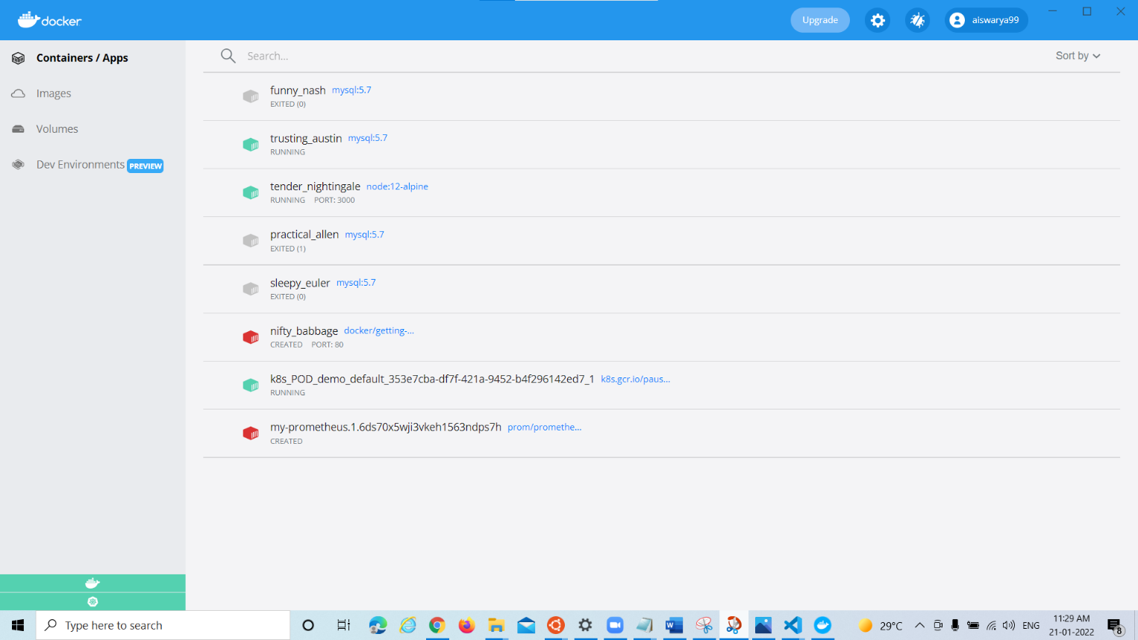

**ENABLE DOCKER SWARM:**

PS C:\Users\LENOVO\kubernetes> docker swarm init

Error response from daemon: This node is already part of a swarm. Use "docker swarm leave" to leave this swarm and join another one.

PS C:\Users\LENOVO\kubernetes> docker swarm join --token

flag needs an argument: --token

See 'docker swarm join --help'.

PS C:\Users\LENOVO\kubernetes> docker service create --name demo alpine:3.5 ping 8.8.8.8

m1syxnaeg8wfq3bprrb8bh7c9

overall progress: 1 out of 1 tasks

1/1: running [==================================================>]

verify: Service converged

PS C:\Users\LENOVO\kubernetes> docker service ps demo

ID NAME IMAGE NODE DESIRED STATE CURRENT STATE ERROR PORTS

8xljnumu17sa demo.1 alpine:3.5 docker-desktop Running Running 22 seconds ago

PS C:\Users\LENOVO\kubernetes> docker service logs demo

demo.1.qj1l2luparhy@docker-desktop | PING 8.8.8.8 (8.8.8.8): 56 data bytes

demo.1.qj1l2luparhy@docker-desktop | 64 bytes from 8.8.8.8: seq=0 ttl=37 time=651.051 ms

demo.1.qj1l2luparhy@docker-desktop | 64 bytes from 8.8.8.8: seq=1 ttl=37 time=20.763 ms

demo.1.qj1l2luparhy@docker-desktop | 64 bytes from 8.8.8.8: seq=2 ttl=37 time=20.271 ms

demo.1.qj1l2luparhy@docker-desktop | 64 bytes from 8.8.8.8: seq=3 ttl=37 time=20.788 ms

demo.1.qj1l2luparhy@docker-desktop | 64 bytes from 8.8.8.8: seq=4 ttl=37 time=23.298 ms

demo.1.qj1l2luparhy@docker-desktop | 64 bytes from 8.8.8.8: seq=5 ttl=37 time=19.948 ms

demo.1.qj1l2luparhy@docker-desktop | 64 bytes from 8.8.8.8: seq=6 ttl=37 time=27.578 ms

demo.1.qj1l2luparhy@docker-desktop | 64 bytes from 8.8.8.8: seq=7 ttl=37 time=24.749 ms

demo.1.qj1l2luparhy@docker-desktop | 64 bytes from 8.8.8.8: seq=8 ttl=37 time=29.324 ms

demo.1.qj1l2luparhy@docker-desktop | 64 bytes from 8.8.8.8: seq=9 ttl=37 time=24.405 ms

demo.1.qj1l2luparhy@docker-desktop | 64 bytes from 8.8.8.8: seq=10 ttl=37 time=26.353 ms

demo.1.qj1l2luparhy@docker-desktop | 64 bytes from 8.8.8.8: seq=11 ttl=37 time=32.346 ms

demo.1.qj1l2luparhy@docker-desktop | 64 bytes from 8.8.8.8: seq=12 ttl=37 time=24.870 ms

demo.1.qj1l2luparhy@docker-desktop | 64 bytes from 8.8.8.8: seq=13 ttl=37 time=25.817 ms

demo.1.qj1l2luparhy@docker-desktop | 64 bytes from 8.8.8.8: seq=14 ttl=37 time=28.961 ms

demo.1.qj1l2luparhy@docker-desktop | 64 bytes from 8.8.8.8: seq=15 ttl=37 time=19.771 ms

demo.1.qj1l2luparhy@docker-desktop | 64 bytes from 8.8.8.8: seq=16 ttl=37 time=39.547 ms

demo.1.qj1l2luparhy@docker-desktop | 64 bytes from 8.8.8.8: seq=17 ttl=37 time=23.428 ms

demo.1.qj1l2luparhy@docker-desktop | 64 bytes from 8.8.8.8: seq=18 ttl=37 time=19.799 ms

demo.1.qj1l2luparhy@docker-desktop | 64 bytes from 8.8.8.8: seq=19 ttl=37 time=25.429 ms

demo.1.qj1l2luparhy@docker-desktop | 64 bytes from 8.8.8.8: seq=20 ttl=37 time=21.180 ms

demo.1.qj1l2luparhy@docker-desktop | 64 bytes from 8.8.8.8: seq=21 ttl=37 time=25.773 ms

demo.1.qj1l2luparhy@docker-desktop | 64 bytes from 8.8.8.8: seq=22 ttl=37 time=24.606 ms

demo.1.qj1l2luparhy@docker-desktop | 64 bytes from 8.8.8.8: seq=23 ttl=37 time=24.905 ms

demo.1.qj1l2luparhy@docker-desktop | 64 bytes from 8.8.8.8: seq=24 ttl=37 time=27.593 ms

demo.1.qj1l2luparhy@docker-desktop | 64 bytes from 8.8.8.8: seq=25 ttl=37 time=25.065 ms

demo.1.qj1l2luparhy@docker-desktop | 64 bytes from 8.8.8.8: seq=26 ttl=37 time=23.020 ms

demo.1.qj1l2luparhy@docker-desktop | 64 bytes from 8.8.8.8: seq=27 ttl=37 time=1001.099 ms

demo.1.qj1l2luparhy@docker-desktop | 64 bytes from 8.8.8.8: seq=28 ttl=37 time=212.101 ms

demo.1.qj1l2luparhy@docker-desktop | 64 bytes from 8.8.8.8: seq=29 ttl=37 time=239.820 ms

demo.1.qj1l2luparhy@docker-desktop | 64 bytes from 8.8.8.8: seq=30 ttl=37 time=24.568 ms

demo.1.qj1l2luparhy@docker-desktop | 64 bytes from 8.8.8.8: seq=31 ttl=37 time=20.746 ms

demo.1.qj1l2luparhy@docker-desktop | 64 bytes from 8.8.8.8: seq=32 ttl=37 time=21.910 ms

demo.1.qj1l2luparhy@docker-desktop | 64 bytes from 8.8.8.8: seq=33 ttl=37 time=21.586 ms

demo.1.qj1l2luparhy@docker-desktop | 64 bytes from 8.8.8.8: seq=34 ttl=37 time=23.885 ms

demo.1.qj1l2luparhy@docker-desktop | 64 bytes from 8.8.8.8: seq=35 ttl=37 time=24.505 ms

demo.1.qj1l2luparhy@docker-desktop | 64 bytes from 8.8.8.8: seq=36 ttl=37 time=20.290 ms

demo.1.qj1l2luparhy@docker-desktop | 64 bytes from 8.8.8.8: seq=37 ttl=37 time=24.335 ms

demo.1.qj1l2luparhy@docker-desktop | 64 bytes from 8.8.8.8: seq=38 ttl=37 time=146.259 ms

demo.1.qj1l2luparhy@docker-desktop | 64 bytes from 8.8.8.8: seq=39 ttl=37 time=53.497 ms

demo.1.qj1l2luparhy@docker-desktop | 64 bytes from 8.8.8.8: seq=40 ttl=37 time=228.068 ms

demo.1.qj1l2luparhy@docker-desktop | 64 bytes from 8.8.8.8: seq=41 ttl=37 time=21.197 ms

demo.1.qj1l2luparhy@docker-desktop | 64 bytes from 8.8.8.8: seq=42 ttl=37 time=20.269 ms

demo.1.qj1l2luparhy@docker-desktop | 64 bytes from 8.8.8.8: seq=43 ttl=37 time=21.687 ms

demo.1.qj1l2luparhy@docker-desktop | 64 bytes from 8.8.8.8: seq=44 ttl=37 time=22.157 ms

demo.1.qj1l2luparhy@docker-desktop | 64 bytes from 8.8.8.8: seq=45 ttl=37 time=20.603 ms

demo.1.qj1l2luparhy@docker-desktop | 64 bytes from 8.8.8.8: seq=46 ttl=37 time=73.364 ms

demo.1.qj1l2luparhy@docker-desktop | 64 bytes from 8.8.8.8: seq=47 ttl=37 time=32.650 ms

demo.1.qj1l2luparhy@docker-desktop | 64 bytes from 8.8.8.8: seq=48 ttl=37 time=23.123 ms

demo.1.qj1l2luparhy@docker-desktop | 64 bytes from 8.8.8.8: seq=49 ttl=37 time=19.197 ms

demo.1.qj1l2luparhy@docker-desktop | 64 bytes from 8.8.8.8: seq=50 ttl=37 time=37.383 ms

demo.1.qj1l2luparhy@docker-desktop | 64 bytes from 8.8.8.8: seq=51 ttl=37 time=29.114 ms

demo.1.qj1l2luparhy@docker-desktop | 64 bytes from 8.8.8.8: seq=52 ttl=37 time=407.769 ms

demo.1.qj1l2luparhy@docker-desktop | 64 bytes from 8.8.8.8: seq=53 ttl=37 time=229.449 ms

demo.1.qj1l2luparhy@docker-desktop | 64 bytes from 8.8.8.8: seq=54 ttl=37 time=4398.019 ms

demo.1.qj1l2luparhy@docker-desktop | 64 bytes from 8.8.8.8: seq=55 ttl=37 time=3318.091 ms

demo.1.qj1l2luparhy@docker-desktop | 64 bytes from 8.8.8.8: seq=56 ttl=37 time=2316.264 ms

demo.1.qj1l2luparhy@docker-desktop | 64 bytes from 8.8.8.8: seq=57 ttl=37 time=1396.507 ms

demo.1.qj1l2luparhy@docker-desktop | 64 bytes from 8.8.8.8: seq=58 ttl=37 time=146.384 ms

demo.1.qj1l2luparhy@docker-desktop | 64 bytes from 8.8.8.8: seq=59 ttl=37 time=248.590 ms

demo.1.qj1l2luparhy@docker-desktop | 64 bytes from 8.8.8.8: seq=60 ttl=37 time=356.977 ms

demo.1.qj1l2luparhy@docker-desktop | 64 bytes from 8.8.8.8: seq=61 ttl=37 time=1415.437 ms

demo.1.qj1l2luparhy@docker-desktop | 64 bytes from 8.8.8.8: seq=62 ttl=37 time=905.339 ms

demo.1.qj1l2luparhy@docker-desktop | 64 bytes from 8.8.8.8: seq=63 ttl=37 time=21.945 ms

demo.1.qj1l2luparhy@docker-desktop | 64 bytes from 8.8.8.8: seq=64 ttl=37 time=25.851 ms

demo.1.qj1l2luparhy@docker-desktop | 64 bytes from 8.8.8.8: seq=65 ttl=37 time=150.722 ms

demo.1.qj1l2luparhy@docker-desktop | 64 bytes from 8.8.8.8: seq=66 ttl=37 time=31.953 ms

demo.1.qj1l2luparhy@docker-desktop | 64 bytes from 8.8.8.8: seq=67 ttl=37 time=28.268 ms

demo.1.qj1l2luparhy@docker-desktop | 64 bytes from 8.8.8.8: seq=68 ttl=37 time=28.664 ms

demo.1.qj1l2luparhy@docker-desktop | 64 bytes from 8.8.8.8: seq=69 ttl=37 time=24.114 ms

demo.1.qj1l2luparhy@docker-desktop | 64 bytes from 8.8.8.8: seq=70 ttl=37 time=24.053 ms

demo.1.qj1l2luparhy@docker-desktop | 64 bytes from 8.8.8.8: seq=71 ttl=37 time=25.252 ms

demo.1.qj1l2luparhy@docker-desktop | 64 bytes from 8.8.8.8: seq=72 ttl=37 time=27.546 ms

demo.1.qj1l2luparhy@docker-desktop | 64 bytes from 8.8.8.8: seq=73 ttl=37 time=46.599 ms

demo.1.qj1l2luparhy@docker-desktop | 64 bytes from 8.8.8.8: seq=74 ttl=37 time=27.453 ms

demo.1.qj1l2luparhy@docker-desktop | 64 bytes from 8.8.8.8: seq=75 ttl=37 time=23.839 ms

demo.1.qj1l2luparhy@docker-desktop | 64 bytes from 8.8.8.8: seq=76 ttl=37 time=19.517 ms

demo.1.qj1l2luparhy@docker-desktop | 64 bytes from 8.8.8.8: seq=77 ttl=37 time=31.814 ms

demo.1.qj1l2luparhy@docker-desktop | 64 bytes from 8.8.8.8: seq=78 ttl=37 time=22.697 ms

demo.1.qj1l2luparhy@docker-desktop | 64 bytes from 8.8.8.8: seq=79 ttl=37 time=21.857 ms

demo.1.qj1l2luparhy@docker-desktop | 64 bytes from 8.8.8.8: seq=80 ttl=37 time=21.386 ms

demo.1.qj1l2luparhy@docker-desktop | 64 bytes from 8.8.8.8: seq=81 ttl=37 time=20.929 ms

demo.1.qj1l2luparhy@docker-desktop | 64 bytes from 8.8.8.8: seq=82 ttl=37 time=34.644 ms

demo.1.qj1l2luparhy@docker-desktop | 64 bytes from 8.8.8.8: seq=83 ttl=37 time=19.577 ms

PS C:\Users\LENOVO\kubernetes> docker service rm demo

demo

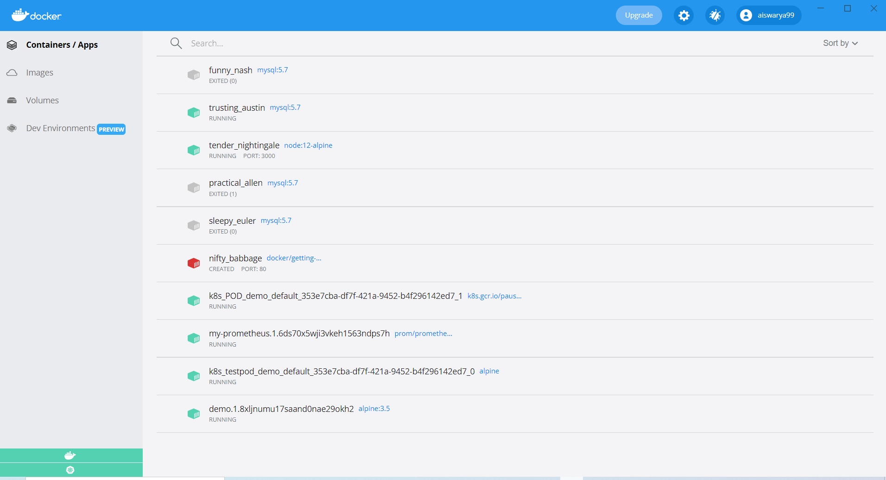

**DEPLOY TO KUBERENETES:**

apiVersion: apps/v1

kind: Deployment

metadata:

  name: bb-demo

  namespace: default

spec:

  replicas: 1

  selector:

    matchLabels:

      bb: web

  template:

    metadata:

      labels:

        bb: web

    spec:

      containers:

      - name: bb-site

        image: aiswarya99/getting-started

---

apiVersion: v1

kind: Service

metadata:

  name: bb-entrypoint

  namespace: default

spec:

  type: NodePort

  selector:

    bb: web

  ports:

  - port: 3000

    targetPort: 3000

    nodePort: 30000

Windows PowerShell

Copyright (C) Microsoft Corporation. All rights reserved.

Try the new cross-platform PowerShell https://aka.ms/pscore6

PS C:\Users\LENOVO\kubernetes> kubectl apply -f bb.yaml

deployment.apps/bb-demo created

service/bb-entrypoint created

PS C:\Users\LENOVO\kubernetes> kubectl get deployments

NAME READY UP-TO-DATE AVAILABLE AGE

bb-demo 0/1 1 0 25s

PS C:\Users\LENOVO\kubernetes> kubectl get services

NAME TYPE CLUSTER-IP EXTERNAL-IP PORT(S) AGE

kubernetes ClusterIP 10.96.0.1 <none> 443/TCP 4h12m

PS C:\Users\LENOVO\kubernetes> kubectl delete -f bb.yaml

deployment.apps "bb-demo" deleted

service "bb-entrypoint" deleted

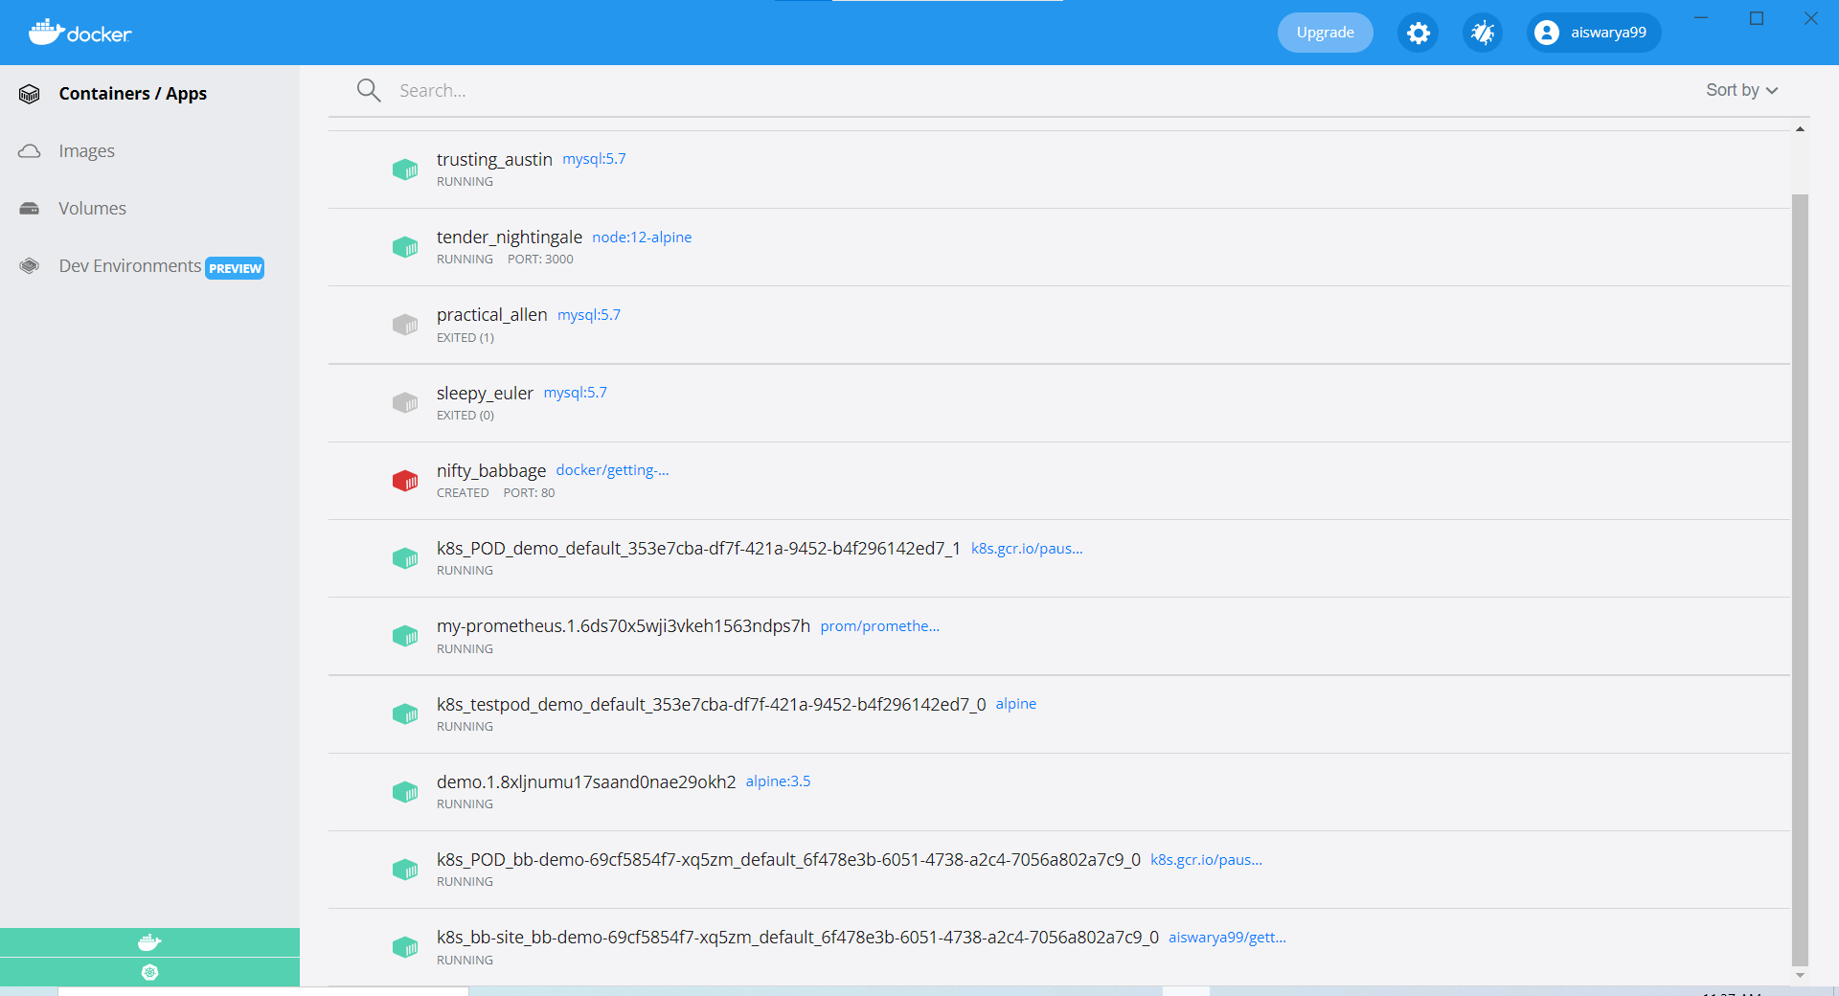

**DEPLOY TO SWARM:**

version: '3.7'

services:

  bb-app:

    image: aiswarya99/getting-started

    ports:

      - "8000:3000"

Windows PowerShell

Copyright (C) Microsoft Corporation. All rights reserved.

Try the new cross-platform PowerShell https://aka.ms/pscore6

PS C:\Users\LENOVO\kubernetes> docker stack deploy -c bb-stack.yaml demo

Creating network demo_default

Creating service demo_bb-app

PS C:\Users\LENOVO\kubernetes> docker service ls

ID NAME MODE REPLICAS IMAGE PORTS

qy83p7sp6fyo demo replicated 1/1 alpine:3.5

b5vmywq1xdyv demo_bb-app replicated 1/1 aiswarya99/getting-started:latest *:8000->3000/tcp

26tqxfagqsq1 my-prometheus replicated 1/1 prom/prometheus:latest *:9090->9090/tcp

PS C:\Users\LENOVO\kubernetes> docker stack rm demo

Removing service demo_bb-app

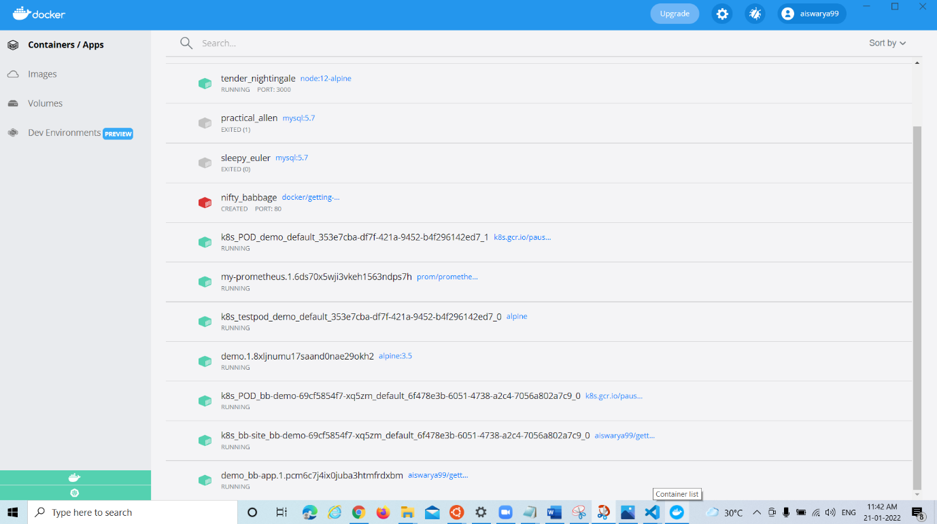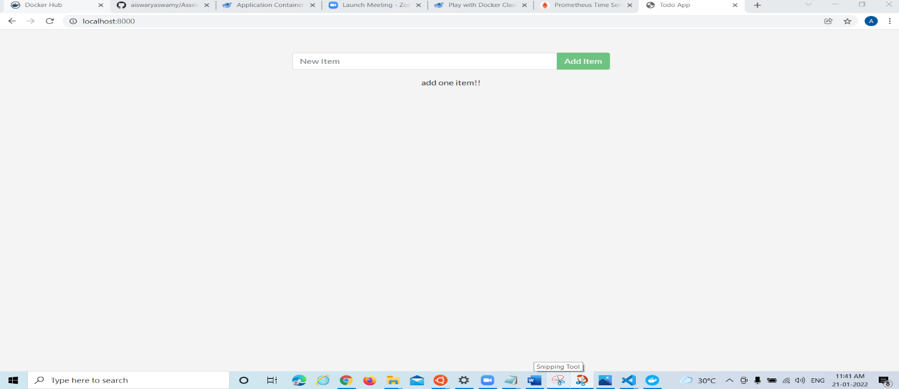Removing network demo_default

**PROMETHEUS**

**Prometheus.yml -**

# my global config

global:

  scrape_interval:     15s # Set the scrape interval to every 15 seconds. Default is every 1 minute.

  evaluation_interval: 15s # Evaluate rules every 15 seconds. The default is every 1 minute.

  # scrape_timeout is set to the global default (10s).

  # Attach these labels to any time series or alerts when communicating with

  # external systems (federation, remote storage, Alertmanager).

  external_labels:

      monitor: 'codelab-monitor'

# Load rules once and periodically evaluate them according to the global 'evaluation_interval'.

rule_files:

  # - "first.rules"

  # - "second.rules"

# A scrape configuration containing exactly one endpoint to scrape:

# Here it's Prometheus itself.

scrape_configs:

  # The job name is added as a label `job=<job_name>` to any timeseries scraped from this config.

  - job_name: 'prometheus'

    # metrics_path defaults to '/metrics'

    # scheme defaults to 'http'.

    static_configs:

      - targets: ['host.docker.internal:9090'] # Only works on Docker Desktop for Windows

  - job_name: 'docker'

         # metrics_path defaults to '/metrics'

         # scheme defaults to 'http'.

    static_configs:

      - targets: ['192.168.65.1:9323']

**Deamon.json:**

{

    "metrics-addr" : "127.0.0.1:9323",

    "experimental" : true

}

PS C:\tmp> cd ..

PS C:\> docker service create --replicas 1 --name my-prometheus `

>> --mount type=bind,source=c:/tmp/prometheus.yml,destination=/etc/prometheus/prometheus.yml `

>> --publish published=9090,target=9090,protocol=tcp `

>> prom/prometheus

image prom/prometheus:latest could not be accessed on a registry to record

its digest. Each node will access prom/prometheus:latest independently,

possibly leading to different nodes running different

versions of the image.

j7cv9mqf0fo37kutkf0z9ydcs

overall progress: 1 out of 1 tasks

1/1: running [==================================================>]

verify: Service converged

